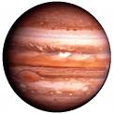 | 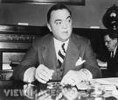 | 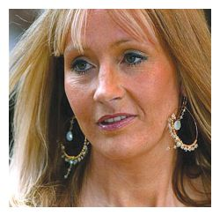 |  | 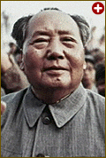
1 Jupiter | 2 J Edgar Hoover | 3 J K Rowling |  | 4 Mao Tse Tung
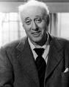 |  | 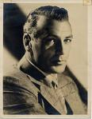 |  | 
5 Alistair Sim | 6 Barbara Windsor | 7 Gary Cooper | 8 Ginger (Donald) McCain
 | 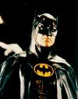 | 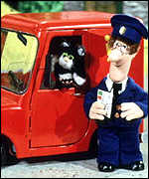 |  | 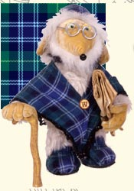
9 Kirsten Dunst | 10 Michael Keaton | 11 Postman Pat and Jess |  | 12 Bulgaria (Womble)
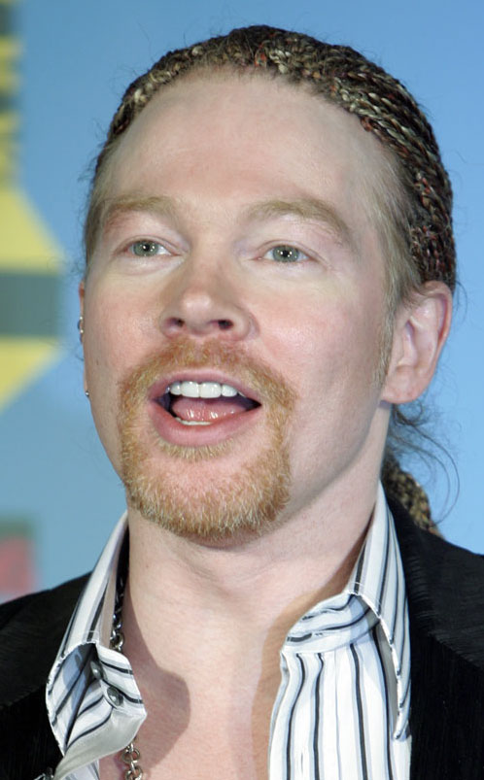 | 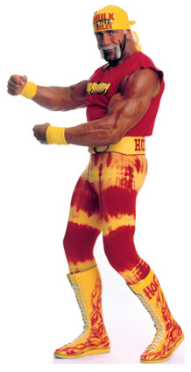 | 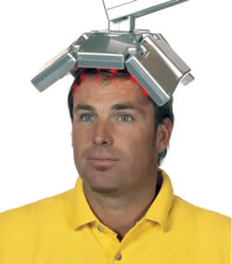 |  | 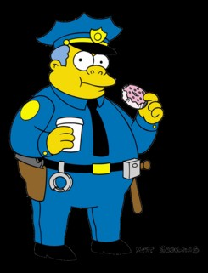
13 Axl Rose | 14 Hulk Hogan | 15 Shane Warne |  | 16 Chief Wiggum
 | 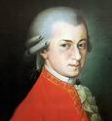 |  |  | 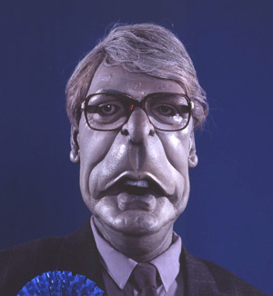
17 Gail Platt (Helen Worth) | 18 Mozart | 19 Roobarb and Custard |  | 20 John Major (from Spitting Image)

